Paragraphing in manuscript writing
Many students and junior scientists face similar difficulties and make similar mistakes in manuscript writing. Writing becomes time consuming in a highly inefficient and frustrating process to produce a poor initial draft that has fundamental structural and stylistic flaws. Following a structured approach and basic guidelines of manuscript writing can resolve that issue¹
A manuscript is essentially a collection of paragraphs that follow a traditional flow². Paragraphs are units of writing larger than a sentence and smaller than a section and generally express a single idea or topic³. Paragraphing can improve clarity and organization in medical writing⁴.
Each paragraph should extend from the topic sentence following the “MEAL plan,”i.e. “M” stands for the main topic; “E,” for the evidence that supports or refutes the topic sentence; “A,” for analysis and its importance; and “L,” for the link back to the larger claim (ie, the overall topic of the paper)².

“Before even beginning to put words on the page, it is important to have an idea of how your ideas will be sequenced, divided, and organized throughout your whole text. Once it is clear what the general outline of ideas and sub-ideas will be, it should be more apparent what idea each paragraph should communicate, and, once it is clear what the main idea of a paragraph is, the structure of that paragraph should follow.”³ Gray, J. 2019
“A paragraph has three main components: a topic sentence, supporting sentences, and a concluding sentence. The topic sentence is usually the first sentence of the paragraph; it states the paragraph’s central concept or argument. Often, a topic sentence introduces a new concept and/or transitions from the previous concept by showing the relationship between the two. Supporting sentences provide explanations, evidence, and other details related to the paragraph’s main concept. Paragraphs typically end with concluding sentences, which provide the reader with a sense of closure. A concluding sentence may take many forms, including a brief summary of the paragraph’s information or a statement about the implications of that information.”³ Kristin Messuri, Ph.D 2016
You can use a paragraph either (i) to describe or define (ii) to classify or to analyze (iii) to provide a narrative or process (iv) to make an argument (v) to compare and contrast or (vi) to qualify.
- Description or definition paragraphs: background in the introduction, study participants in the methods section, summary of your results in the discussion section.
- Classification or analysis paragraphs: literature review to identify a literature gap.
- Narrative or process paragraphs: give the sequence of events in time to describe the procedure in the methods section using first, second, third, then, and finally.
- Argumentative paragraphs: the interpretation and implications of your findings in the discussion section to show a logical reasoning.
- Compare and contrast paragraphs: to show similarity or difference in the background section of the introduction or in the discussion section (your results versus the literature).
- Qualification paragraphs: to show the limitations in the background section or at the end of the discussion. The clue is the word used: however, but, nonetheless, regardless, despite this, etc…
Effective paragraphs have both coherence and cohesion. Coherence refers to the clarity and comprehensibility or unity of a paragraph whereas cohesion refers to the sentence-level structures and words that foster this sense of unity³⁻⁵.
References
- Arold, S. T. (2020). Efficient manuscript writing in six steps. KAUST Research Repository. https://doi.org/10.25781/KAUST-6MNY2
- Hicks, R. W. (2017). Writing: Do Make a MEAL of It!. Clinician Reviews, 27(7), 8-10.
- Gray, J. (2019). Paragraphs in medical writing. AME Medical Journal, 4. doi:10.21037/amj.2019.05.02
- Messuri, K. (2016). Writing Effective Paragraphs. The Southwest Respiratory and Critical Care Chronicles, 4(15), 86-88. Retrieved from https://pulmonarychronicles.com/index.php/pulmonarychronicles/article/view/290
- Schultz, D.M. (2009). Constructing Effective Paragraphs. In: Eloquent Science. American Meteorological Society, Boston, MA. https://doi.org/10.1007/978-1-935704-03-4_8
Annex
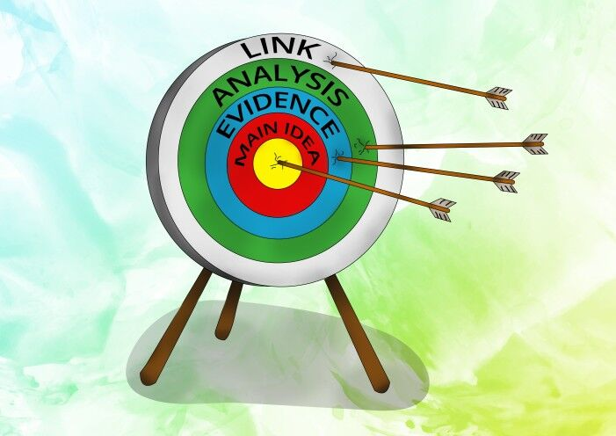

Figure 1: The MEAL plan available at https://blog.papertrue.com/meal-paragraph/ consulted on July 01, 2023.

